PROJECT TEMPLATE

INTRODUCTION;

Define Your Objective: Begin by clarifying your purpose. Are you trying to inform, entertain, promote, educate, or inspire your audience? Understanding your goal is crucial to crafting a post that aligns with your intentions.

Know Your Audience: Consider who you're addressing. Understanding your target demographic's preferences, interests, and pain points will help tailor your post to resonate with them.

Choose the Right Platform: Different social media platforms cater to different types of content and audiences. Select the platform that best suits your message. For example, Instagram is great for visuals, while Twitter is known for short, concise updates.

Craft a Captivating Headline or Caption: The first few words are crucial. Use a compelling headline or caption that grabs attention, conveys the essence of your post, and encourages further engagement.

Create High-Quality Visuals: Visual content often performs better on social media. Whether it's an image, video, infographic, or meme, ensure it's high-quality, relevant, and visually appealing.

Tell a Story: People connect with stories. Whether you're sharing a personal experience, a customer success story, or a narrative related to your message, weaving a story can make your post more relatable and memorable.

Incorporate Relevant Hashtags: Using hashtags can increase the discoverability of your post. Research and include relevant hashtags to expand your reach to a broader audience.

Add a Call to Action (CTA): Encourage your audience to take a specific action, such as liking, sharing, commenting, or clicking a link. A clear CTA guides your audience on what to do next.

Keep It Concise: Social media users have short attention spans. Be concise and to the point, conveying your message effectively in a few sentences or a short video.

Engage with Your Audience: After posting, don't forget to engage with comments and messages from your audience. Respond to questions, acknowledge comments, and build a sense of community.

Schedule or Time It Right: Timing matters on social media. Use scheduling tools to post at times when your target audience is most active, which can vary by platform.

Measure and Analyze: After your post has been live for a while, review its performance. Most social media platforms provide analytics that can help you understand what worked and what didn't. Use these insights to refine your future posts.

Remember, the key to creating a successful social media post is to strike a balance between creativity and strategy. Experiment with different approaches, and over time, you'll gain a better understanding of what resonates with your audience and how to create posts that achieve your objectives.

EMPATHYMAP  
  
  
 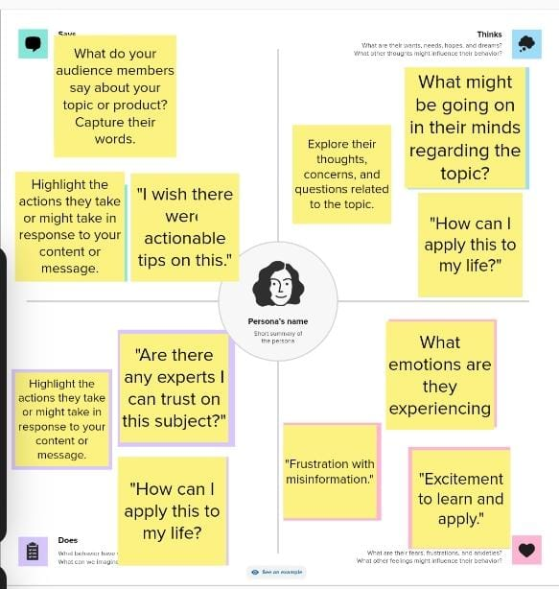

BRAINSTROMING  
  
  
  
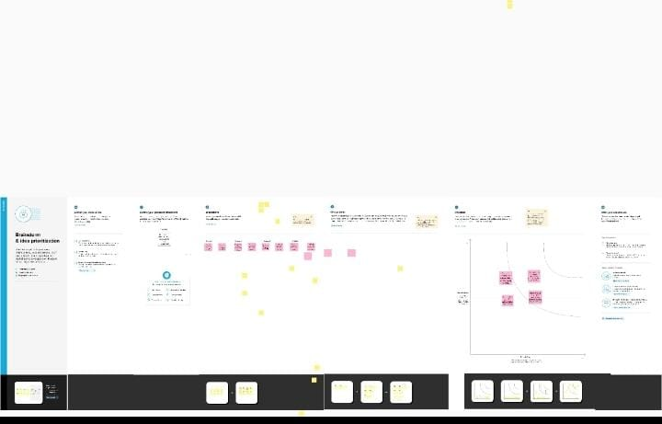  
  
  
  
  
  
  
PROJECT RESULT  
  
  


ADVANTAGE OF SOCIAL MEDIA;

Social media has become an integral part of modern life, and it offers several advantages for individuals, businesses, and society as a whole. Here are some of the key advantages of social media:

Communication and Connectivity:

Social media platforms enable people to connect with friends, family, and acquaintances, regardless of geographical boundaries.

It provides a convenient way to stay in touch with loved ones, especially when physical presence is not possible.

Information and Awareness:

Social media is a powerful source of information and news, providing updates on a wide range of topics in real-time.

It's a valuable tool for staying informed about current events, trends, and developments.

Education and Learning:

Social media can be a platform for learning, as it hosts educational content, webinars, and courses.

It offers opportunities for sharing knowledge and accessing resources for personal and professional development.

Networking and Career Opportunities:

Platforms like LinkedIn help professionals network, connect with potential employers, and find job opportunities.

Social media can be a valuable tool for building a personal brand and showcasing skills.

Business Marketing and Promotion:

Social media is a cost-effective way for businesses to market their products and services, reach a global audience, and engage with customers.

Advertising on platforms like Facebook and Instagram can be highly targeted, increasing the chances of reaching the right audience.

Community Building:

Social media allows the formation of online communities around shared interests, hobbies, or causes.

These communities provide a sense of belonging and can be a source of support.

Political Activism and Social Change:

Social media has played a crucial role in organizing and mobilizing for social and political causes.

It enables individuals to raise awareness about important issues and advocate for change.

Entertainment and Creativity:

Social media platforms like YouTube, Instagram, and TikTok provide a space for creativity, where people can share their art, music, and other talents.

It offers a platform for entertainment, including videos, memes, and viral content.

Customer Support and Feedback:

Companies can use social media to provide customer support, address concerns, and gather feedback.

Customers can easily reach out to brands for assistance.

Global Reach and Influence:

Social media allows individuals and organizations to have a global reach and influence public opinion.

Celebrities, influencers, and thought leaders can use it to spread their messages.

Data and Insights:

Social media provides valuable data and insights about user behavior and preferences, which can inform decision-making and marketing strategies.

While social media has numerous advantages, it's essential to be mindful of potential drawbacks, such as privacy concerns, misinformation, and the potential for addiction. Balancing the benefits with responsible use is key to making the most of these platforms.

DIS ADVANTAGE OF SOCIAL MEDIA;

Social media has undoubtedly transformed the way we communicate and share information, but it also comes with several disadvantages. Here are some of the common disadvantages of social media:

Privacy Concerns:One of the biggest drawbacks of social media is the potential for privacy breaches. Users often share personal information, and there's a risk of this information being misused or falling into the wrong hands.

Cyberbullying and Harassment:Social media platforms can be breeding grounds for cyberbullying and harassment. The anonymity and distance provided by the internet can lead to abusive and hurtful behavior.

Mental Health Issues:Extensive use of social media has been associated with mental health issues such as anxiety, depression, and loneliness. Constant comparison to others' curated online lives can lead to low self-esteem.

Addiction:The addictive nature of social media can lead to time-wasting and procrastination. Excessive use can interfere with productivity and real-life interactions.

Dissemination of Misinformation:False or misleading information can spread rapidly on social media platforms. This misinformation can have real-world consequences and undermine trust in credible sources.

Security Risks:Malicious actors can use social media to launch phishing attacks, spread malware, or engage in identity theft.

Echo Chambers:Social media algorithms tend to show users content that aligns with their existing beliefs and preferences. This can create echo chambers and reinforce existing biases, limiting exposure to diverse perspectives.

Impact on Relationships:Excessive use of social media can strain real-life relationships. Couples may argue about time spent on social media, and misunderstandings can arise from online interactions.

Negative Influence on Self-Image:Many people, especially young users, are affected by the idealized images and lifestyles portrayed on social media. This can lead to body image issues and a sense of inadequacy.

Distraction While Driving:The use of social media while driving has contributed to a rise in distracted driving incidents, leading to accidents and fatalities.

Data Privacy and Security Concerns:The collection and use of personal data by social media companies can raise concerns about surveillance and the potential for data breaches.

It's important to recognize these disadvantages while using social media and take steps to mitigate them, such as being mindful of privacy settings, monitoring screen time, and being critical of the information you encounter online.

